**ST. THEREZA NAMIRYANGO GIRLS’ BOARDING PRIMARY SCHOOL**

**END OF TERM I CONTINUOUS ASSESSMENT 2024**

**P.6 SOCIAL STUDIES WITH RELIGIOUS EDUCATION**

**TIME ALLOWED: 2 HOURS 15 MINUTES**

**NAME______________________________________________STM__**

**SECTION: A (40 MARKS)**

1. How do plants benefit from animals?

________________________________________________________________

2. Give any one reason why farmers harvest their crops in the dry

season.

________________________________________________________________

3. What type of rainfall is received near water bodies and forests?

________________________________________________________________

4. How did the 1900 Buganda agreement affect the Kabaka?

________________________________________________________________

5. In which one way does a low population affect trade activities in an

area?

________________________________________________________________

6. Why is Uganda said to be lying both in the Northern and Southern

hemispheres?

________________________________________________________________

7. Mention any one problem faced by people who live in mountainous

areas.

________________________________________________________________

8. How can over loading of water vessels be a danger to people using

water transport?

________________________________________________________________

9. Give a reason why a wind sock is not found at a weather station.

________________________________________________________________

10. In which way does over cultivation affect land in an area?

________________________________________________________________

11. Why do people move from rural areas to urban areas today?

________________________________________________________________

12. How can creation of jobs in a country help to reduce poverty

among people?

________________________________________________________________ 13. Name any one social service provided to people in your community.

________________________________________________________________

14. State any one way children’s rights are abused.

________________________________________________________________ 15. Give one advantage of plantation farming over subsistence farming.

________________________________________________________________

16. Why is Savanna Vegetation the most suitable for wildlife?

________________________________________________________________

17. Name the mineral wealth that was recently discovered from the

Albertine region.

________________________________________________________________

18. How do people misuse water sources in your area?

________________________________________________________________

19. Name the ethnic group to which the Langi of Northern Uganda belong.

________________________________________________________________

20. Give a reason why most explorers were interested in coming to

Uganda.

________________________________________________________________

21. State one way the Indian coolies contributed to the modern

economy of Uganda.

________________________________________________________________

22. How does altitude influence the climate of a given area?

________________________________________________________________

23. Why did some plain nilotes change to mixed farming when they

entered Uganda?

________________________________________________________________

24. How is Uganda economically affected by being landlocked?

________________________________________________________________

25. Give any one factor that leads to swampy surroundings around

L.Kyoga.

________________________________________________________________

26. Why did the British colonialists introduce indirect rule in Uganda?

________________________________________________________________

27. State any one way of showing respect to the Uganda National flag.

________________________________________________________________

28. Give a reason why schools should encourage pupils to elect their

leaders (prefects).

________________________________________________________________

29. State any one role of the judiciary in a democratic government.

________________________________________________________________

30. Why did King Muteesa 1 turn against the missionaries and yet he

invited them?

________________________________________________________________

31. How did the discovery of farming help early man to live a settled life?

________________________________________________________________

32. What is a market?

________________________________________________________________

33. Why is Bigobyamugenyi important in the history of the Bachwezi?

________________________________________________________________

34. How does family planning help to control population growth?

________________________________________________________________

35. State any one advantage of mixed farming to a farmer.

________________________________________________________________

**For questions 36 - 40, answer Either the Christian Or Islamic question BUT NOT BOTH.**

36. **Either**: Why is there need for a Christian child to have good relationship with others?

________________________________________________________________

**Or**: Why is there need for a Muslim child to have good relationship with others?

________________________________________________________________

37. **Either**: In which way does work create joy to a Christian?

________________________________________________________________

**Or**: In which way does work create joy to a Muslim?

________________________________________________________________

38. **Either**: How did suffering come into the world according to the Bible?

________________________________________________________________

**Or**: How did suffering come into the world according to the Quran?

________________________________________________________________

39. **Either**: Why did God call Abraham?

________________________________________________________________

**Or**: Why did Allah call Prophet Ibrahim?

________________________________________________________________

40. **Either**: In which one way do Christians accept the saviour in their daily lives?

________________________________________________________________

**Or**: In which one way do Muslims accept Prophet Muhammed in their daily lives?

________________________________________________________________

**SECTION B: (60 MARKS)**

41. **Match the weather instruments in list A to their uses in list B.**

**A B**

a) Barometer -measures amount of rainfall

b) Anemometer -measures air pressure

c) Hygrometer -measures the speed of wind

d) Rain gauge -measures humidity

(a) Barometer ___________________________________________________

(b) Anemometer _________________________________________________

(c) Hygrometer __________________________________________________

(d) Rain gauge __________________________________________________

42(a) State any two contributions of the early missionaries to the social

development of Uganda.

i)_____________________________________________________________________

ii)____________________________________________________________________

(b) State any two problems that were faced by early missionaries in

Uganda.

i)_____________________________________________________________________

ii)____________________________________________________________________

43. **Study the map of Uganda below and answer the questions that**

**follow.**

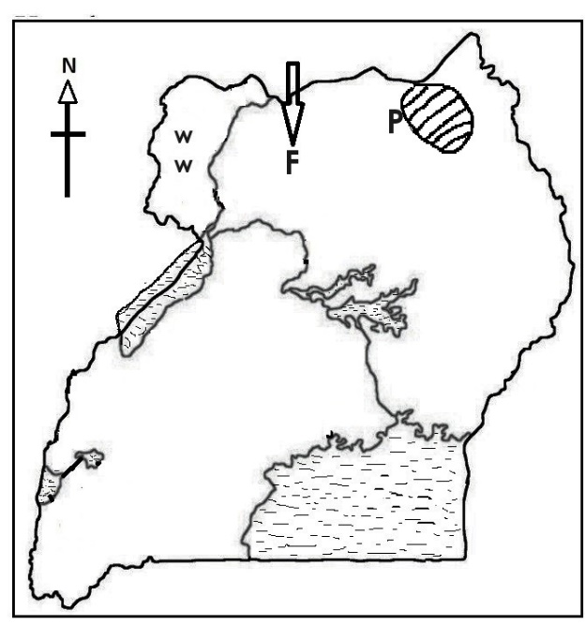

(a) Use letter **R** to locate Kazinga channel on the map.

(b) State any one problem affecting the tourism area marked **P**.

________________________________________________________________

(c) Name any one cash crop grown by the people in area marked **ww**.

________________________________________________________________

(d) Mention any one reason that led to the migration of the tribal

group that followed route marked **F**.

________________________________________________________________ 44(a) Mention any two major roles played by the local council in your community.

i)_____________________________________________________________________

ii)____________________________________________________________________

(b) Name the local council executive responsible for children’s welfare.

________________________________________________________________

(c) In which one way do citizens lead to the violation of their rights?

________________________________________________________________

45a) Write down any two methods used by the British colonialists to spread their rule in Uganda.

i)_____________________________________________________________________

ii)____________________________________________________________________

(b) State any two ways Ugandans reacted towards colonial rule.

i)_____________________________________________________________________

ii)____________________________________________________________________

46(a) Mention any two social effects of unemployment in a country.

i)_____________________________________________________________________

ii)____________________________________________________________________

(b) Mention any two ways the government of Uganda can solve the

problem of unemployment.

i)_____________________________________________________________________

ii)____________________________________________________________________

47(a) Name the symbol on the Uganda coat of arms that represents the

following

i) wildlife of Uganda ____________________________________________

ii) abundant sunshine received in Uganda ________________________

iii) traditional weapon for protection______________________________

iv) traditional means of communication___________________________

48(a) Name any one founder member head of state of EAC.

________________________________________________________________

(b) In which three ways does Uganda benefit from being a member of East African Community?

i)_____________________________________________________________________

ii)____________________________________________________________________

iii)____________________________________________________________________

49. **Study the map of East Africa below and answer questions that follow.**

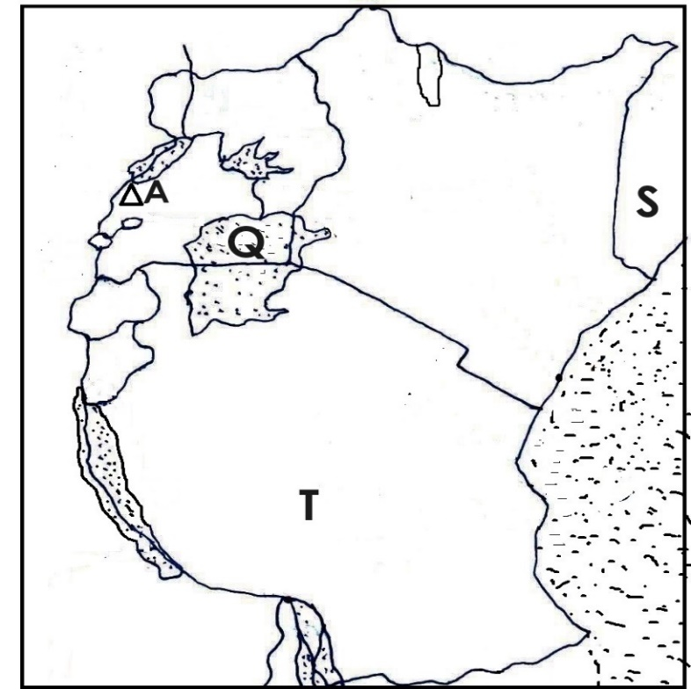

(a) Name the new member state of EAC marked **S**.

________________________________________________________________

(b) Why did Henry Morton Stanley sail around lake marked **Q**?

________________________________________________________________

(c) Mention the town in country **T** where the headquarters of EAC are located.

________________________________________________________________

(d) Why was mountain **A** described as mountains of the moon by Henry Morton Stanley?

________________________________________________________________

50(a) In which one way can parents help schools to develop?

________________________________________________________________

(b) Mention any two ways your school gets funds.

i)_____________________________________________________________________

ii)____________________________________________________________________

(c) Why do some schools fail to meet their basic needs?

________________________________________________________________

For questions 51 – 55, answer **Either Christian Or Islamic** questions **BUT NOT BOTH.**

51. **Either:** (a) How does sin stop a Christian’s body from being the temple of the Holy Spirit?

________________________________________________________________

(b) State any two effects of man’s sin to the world today.

i)_____________________________________________________________________

ii)____________________________________________________________________

(c) Give any one way a Christian can overcome sin.

________________________________________________________________

**Or:** (a) How does sin stop a Moslem’s body from being the temple of Allah?

________________________________________________________________

(b) State any two effects of man’s sin to the world today.

i)_____________________________________________________________________

ii)____________________________________________________________________

(c) Give any one way a Muslim can overcome sin.

_______________________________________________________________

52. **Either**: (a) What is evil according to the Bible?

________________________________________________________________

(b) Give any two examples of social evils in your community.

i)_____________________________________________________________________

ii)____________________________________________________________________

(c) In which one way can social evils affect people in your community?

________________________________________________________________

**Or:** (a) What is evil according to the Quran?

________________________________________________________________

(b) Give any two examples of social evils in your community.

i)_____________________________________________________________________

ii)____________________________________________________________________

(c) In which one way can social evils affect people in your community?

________________________________________________________________

53. **Either**: (a) In which two ways can Christians listen to God’s messages

today?

i)_____________________________________________________________________

ii)____________________________________________________________________

(b) State any two advantages of listening to God’s messages in the Bible.

i)_____________________________________________________________________

ii)____________________________________________________________________

**Or:** (a) In which two ways can a Muslim listen to Allah’s messages today?

i)_____________________________________________________________________

ii)____________________________________________________________________

(b) State any two advantages of listening to Allah’s messages in the Quran.

i)_____________________________________________________________________

ii)____________________________________________________________________

54. **Either**: a) Match names in list **A** to what they are known for in list **B**.

**A B**

1. Simon Peter - He was at first called Levi
2. John - He was the head of the disciples.
3. Nicodemus - Most beloved apostle of Jesus Christ
4. Matthew - buried the body of Jesus

a) Simon Peter ___________________________________________________

b) John ___________________________________________________

c) Nicodemus ___________________________________________________

d) Matthew ___________________________________________________

**Or**: Match names in list **A** to what they are known for in list **B**.

**A B**

1. Abu Baker -was not liked by the enemies of Islam
2. Umar -first successor of Prophet Muhammed
3. Uthman -third Caliph of Prophet Muhammed
4. Ali -was appointed by Abu Baker before his death.

a) Abu Baker ________________________________________________________

b) Umar ________________________________________________________

c) Uthman ________________________________________________________

d) Ali ________________________________________________________

55. **Either:** (a) How is hope important to Christians?

________________________________________________________________

(b) Mention any two reasons for the coming of Jesus into the world.

i)_____________________________________________________________________

ii)____________________________________________________________________

(c) Mention any one Prophet who preached about the coming of Jesus Christ in the Bible.

________________________________________________________________

**Or:**(a) How is hope important to Muslims?

________________________________________________________________

(b) In which two ways is Prophet Muhammed important to the Muslims?

i)_____________________________________________________________________

ii)____________________________________________________________________

(c) Mention the Prophet who received injir according to the Quran.

________________________________________________________________

=====**End**=====